1. General form of the equation of a line is Ax + By + C = 0, where A and B cannot be simultaneously equal 0.
2. In the general form, m = -A/B, y-intercept is -C/B, x-intercept is -C/A
3. Two lines a1x + b1y + c1 = 0 and a2x + b2y + c2 = 0 are **parallel**, iff ***a1b2 = a2b1***.
4. Two lines a1x + b1y + c1 = 0 and a2x + b2y + c2 = 0 are **perpendicular**, iff ***a1a2 + b1b2 = 0***.
5. Distance of a point (x1, y1) from given line, (Ax + By + C) is given by the formula

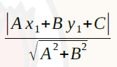

1. Shortest distance between two parallel lines is given by the formula

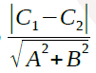

1. If we’ve to fit a line to a set of points, we find the squared-error between each predicted value (as per the equation) and corresponding actual value. Thus, if we’re trying fit the (n) points to the line ***y = mx + c,*** we should try and minimize the sum-squared error.

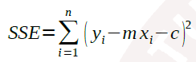

1. Best line fit between a set of pairs of (x, y) will have it slope calculated using

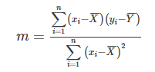

where n is the number of pairs, $\overline{x}$ and $\overline{y}$ are mean value of x-values and y-values respectively.

(Reference: https://www.varsitytutors.com/hotmath/hotmath_help/topics/line-of-best-fit)